EXP:1
% Simplified illustrative model; not a full cellular-network simulation.

clear; clc; close all;

% Illustrative system parameters
totalBandwidthHz = 1e6; % Total bandwidth: 1 MHz fdmaChannelHz = 200e3; % FDMA channel width: 200 kHz tdmaSlots = 8; % Number of TDMA slots per frame processingGain = 64; % CDMA processing gain targetSIRdB = 7; % Minimum acceptable CDMA SIR

% Capacity estimates under the stated assumptions fdmaUsers = floor(totalBandwidthHz / fdmaChannelHz); tdmaUsers = tdmaSlots;

targetSIR = 10^(targetSIRdB / 10);
cdmaUsers = floor(1 + processingGain / targetSIR);

fprintf('Illustrative maximum supported users\n'); fprintf('FDMA: %d users\n', fdmaUsers); fprintf('TDMA: %d users\n', tdmaUsers); fprintf('CDMA: %d users at a target SIR of %.1f dB\n\n', ...
cdmaUsers, targetSIRdB);

% CDMA SIR as the number of simultaneous users increases K = 2:30;
sirLinear = processingGain ./ (K - 1); sirDb = 10 * log10(sirLinear);

% Display a comparison table method = ["FDMA"; "TDMA"; "CDMA"];
supportedUsers = [fdmaUsers; tdmaUsers; cdmaUsers];

results = table(method, supportedUsers); disp(results);

% Plot estimated user capacity figure;
bar(categorical(method), supportedUsers);
ylabel('Illustrative maximum supported simultaneous users'); title('FDMA, TDMA and CDMA: Capacity Estimate'); grid on;

% Plot estimated CDMA SIR as users are added figure;
plot(K, sirDb, 'o-', 'LineWidth', 1.5); hold on;
yline(targetSIRdB, '--r', 'Target SIR'); xlabel('Number of simultaneous CDMA users (K)'); ylabel('Estimated SIR (dB)');
title('Estimated CDMA SIR versus Number of Users'); grid on; hold off;
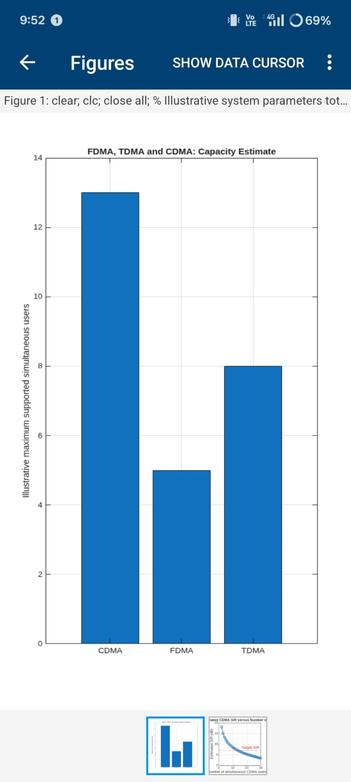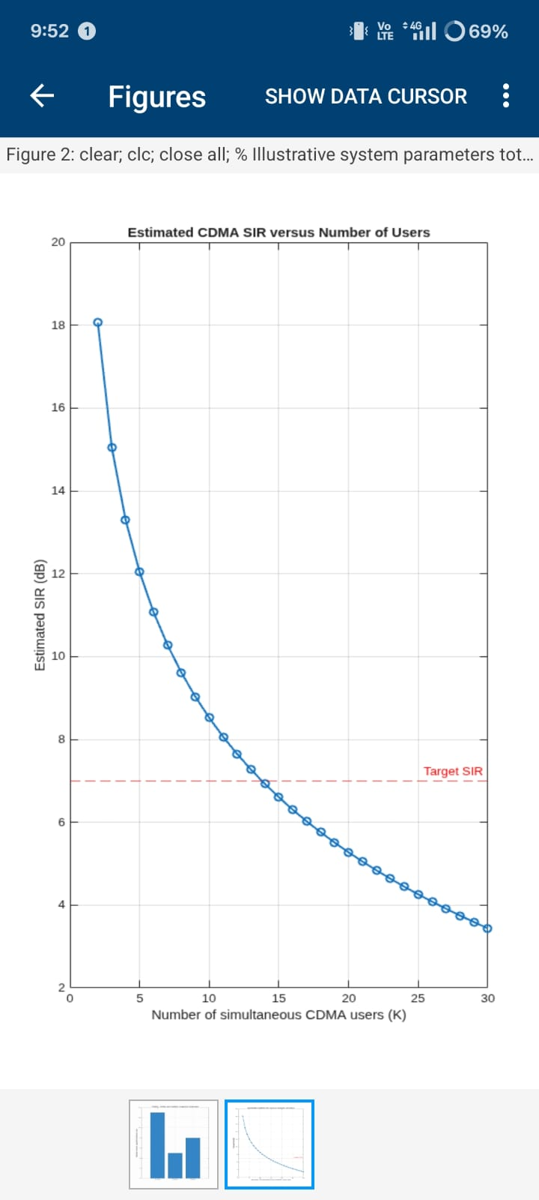

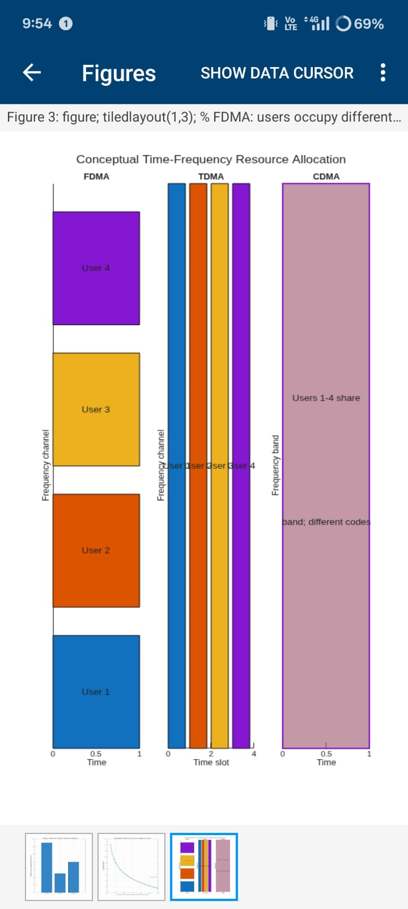
EXP:2
% Experiment 2: simplified hexagonal coverage and handoff clear; clc; close all;

% Baseline assumptions serviceAreaKm2 = 5; radiiKm = [1.0 0.5]; usersPerCell = 30; hexArea = @(R) (3*sqrt(3)/2) .* R.^2;

cellAreaKm2 = hexArea(radiiKm); cellCount = ceil(serviceAreaKm2 ./ cellAreaKm2); estimatedUsers = cellCount .* usersPerCell; capacityTable = table(radiiKm(:), cellAreaKm2(:), cellCount(:), ... repmat(usersPerCell,numel(radiiKm),1), estimatedUsers(:), ...
'VariableNames', {'Radius_km','CellArea_km2','EstimatedCells', ...
'UsersPerCell','IllustrativeUsers'});
disp(capacityTable);

% Plot a 7-cell cluster: central cell plus six neighbors
R = radiiKm(1); centers = [0 0; 1.5*R sqrt(3)*R/2; 1.5*R -sqrt(3)*R/2; ...
0 sqrt(3)*R; 0 -sqrt(3)*R; -1.5*R sqrt(3)*R/2; ...
-1.5*R -sqrt(3)*R/2];
theta = (0:6)*pi/3; % flat-top hexagon vertices figure; hold on; axis equal; grid on; for k = 1:size(centers,1) plot(centers(k,1)+R*cos(theta), centers(k,2)+R*sin(theta), 'k-'); text(centers(k,1),centers(k,2),sprintf('Cell %d',k), ...
'HorizontalAlignment','center'); end
xlabel('x (km)'); ylabel('y (km)');
title('Idealized Seven-Cell Hexagonal Cluster');
hold off;

% Mobile moves across the boundary between centers at x=0 and x=1.5R mobileX = linspace(-0.2*R,1.7*R,300); mobileY = zeros(size(mobileX)); d1 = hypot(mobileX, mobileY); d2 = hypot(mobileX-1.5*R, mobileY); servingCell = ones(size(mobileX)); servingCell(d2 < d1) = 2; handoffIndex = find(diff(servingCell) ~= 0,1,'first') + 1; figure; hold on; grid on; plot(mobileX,d1,'LineWidth',1.5); plot(mobileX,d2,'LineWidth',1.5); if ~isempty(handoffIndex) xline(mobileX(handoffIndex),'--r','Handoff decision'); end xlabel('Mobile x-position (km)'); ylabel('Distance to cell center (km)');
legend('Cell 1','Cell 2','Location','best'); title('Nearest-Center Handoff Approximation'); hold off; figure; stairs(mobileX,servingCell,'LineWidth',1.5); grid on; xlabel('Mobile x-position (km)'); ylabel('Serving-cell ID'); title('Serving Cell Along the Mobile Path');
if ~isempty(handoffIndex) fprintf('Geometric handoff at x = %.3f km\n',mobileX(handoffIndex)); end

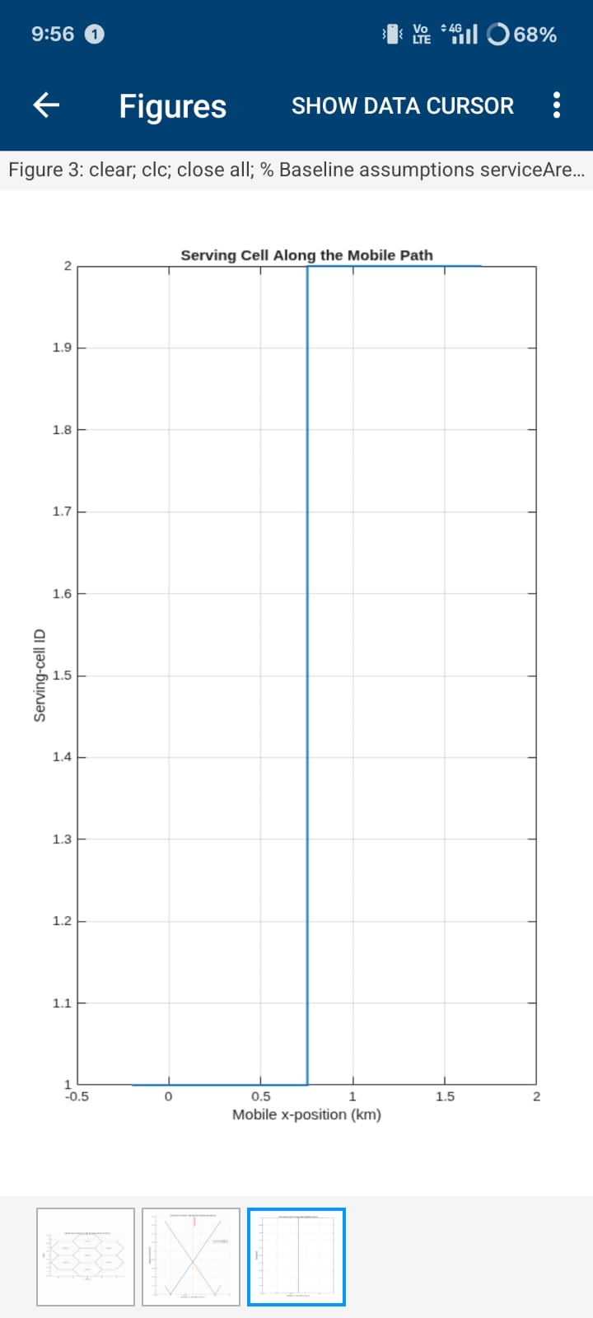
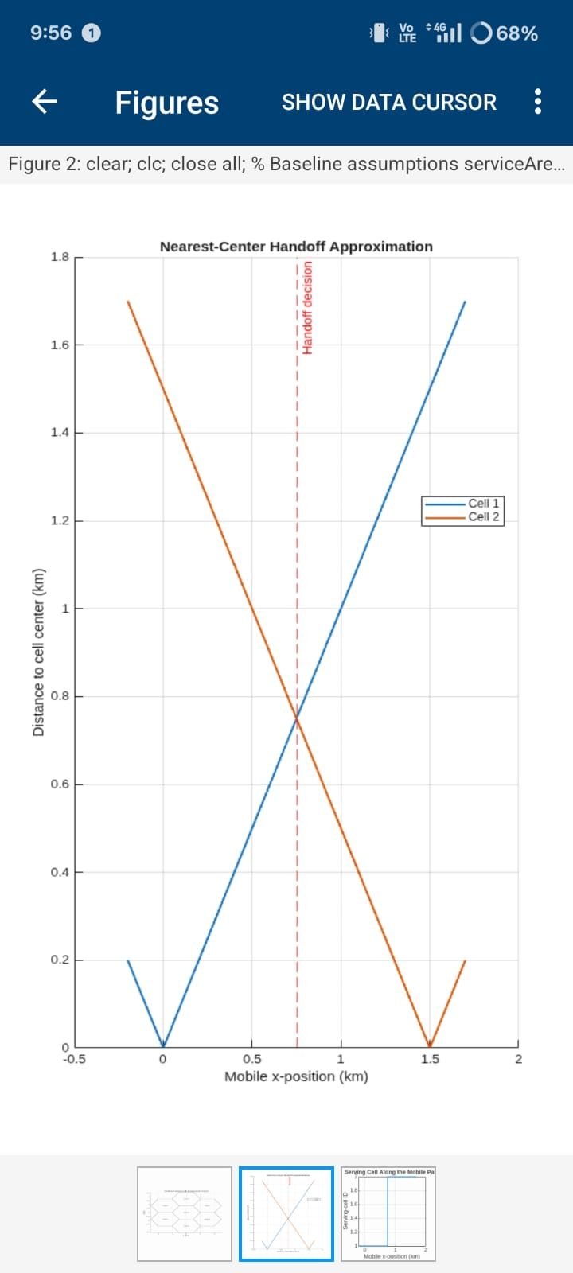

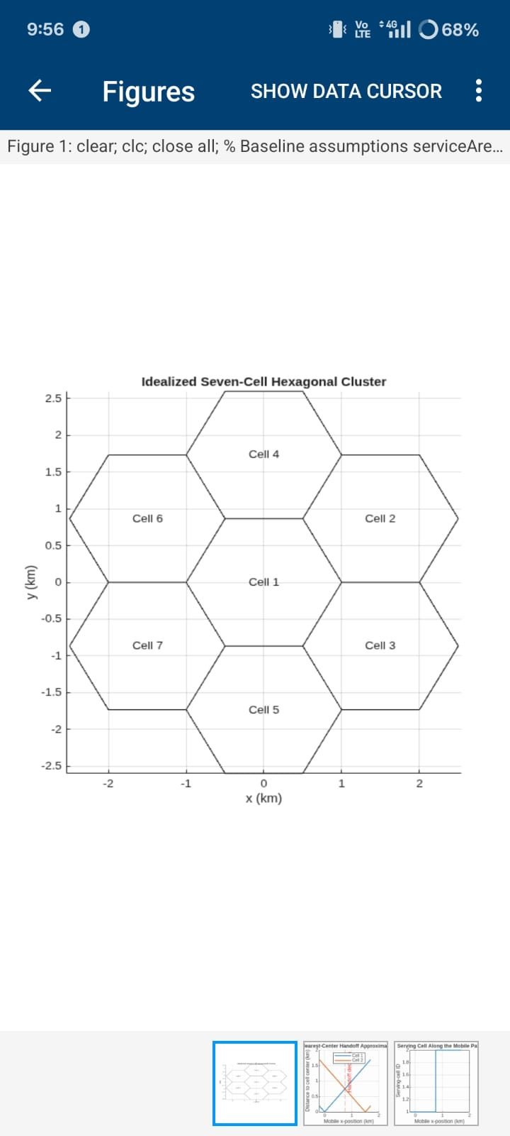

EXP:3
clear; clc; close all;
% Representative bands and link-budget assumptions freqGHz = [0.7 3.5 28]; freqMHz = freqGHz * 1000; bandName = ["Sub-1 GHz"; "Mid-band"; "mmWave"]; txPowerdBm = 30; gtDbi = 0; grDbi = 0; distanceKm = logspace(log10(0.1),log10(2),200); distanceAtPointKm = 0.5;

% Free-space path loss (d in km, f in MHz)
fspl = @(fMHz,dKm) 32.44 + 20*log10(fMHz) + 20*log10(dKm);
lossAtPoint = fspl(freqMHz,distanceAtPointKm); rxAtPoint = txPowerdBm + gtDbi + grDbi - lossAtPoint; linkTable = table(bandName,freqGHz(:),lossAtPoint(:),rxAtPoint(:), ... 'VariableNames',{'Band','Frequency_GHz','FSPL_dB','EstimatedRx_dBm'}); disp(linkTable);

% Path loss and received power over distance
figure; tiledlayout(1,2); nexttile; hold on; grid on; for k=1:numel(freqMHz) plot(distanceKm,fspl(freqMHz(k),distanceKm),'LineWidth',1.5); end
set(gca,'XScale','log'); xlabel('Distance (km)'); ylabel('Path loss (dB)'); legend(bandName,'Location','northwest'); title('Free-Space Path Loss'); nexttile; hold on; grid on; for k=1:numel(freqMHz) rx = txPowerdBm + gtDbi + grDbi - fspl(freqMHz(k),distanceKm); plot(distanceKm,rx,'LineWidth',1.5); end
set(gca,'XScale','log'); xlabel('Distance (km)'); ylabel('Estimated received power (dBm)'); legend(bandName,'Location','southwest'); title('Illustrative Received Power');

% Simple first-tier co-channel reuse estimate
cellRadiusKm = 0.5; reuseN = [1 3 7 12]; pathLossExponent = 3.5;
reuseDistance = sqrt(3*reuseN) * cellRadiusKm; sirLinear = (reuseDistance/cellRadiusKm).^pathLossExponent / 6; sirDb = 10*log10(sirLinear); reuseTable = table(reuseN(:),reuseDistance(:),sirDb(:), ...
'VariableNames',{'ReuseClusterN','ApproxInterfererDistance_km','ApproxSIR_dB'}); disp(reuseTable);
figure; plot(reuseN,sirDb,'o-','LineWidth',1.5); grid on; xlabel('Reuse cluster size N'); ylabel('Approximate SIR (dB)'); title('Simplified Co-Channel SIR versus Reuse Cluster Size');

fprintf('At %.2f km, estimated received powers are:\n',distanceAtPointKm); disp(table(bandName,rxAtPoint(:),'VariableNames',{'Band','Rx_dBm'}));

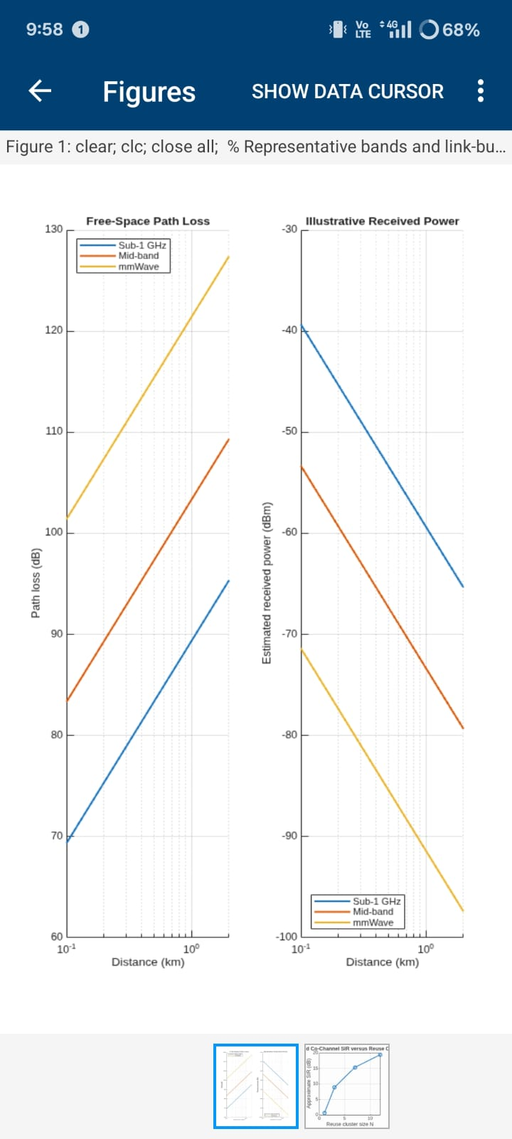
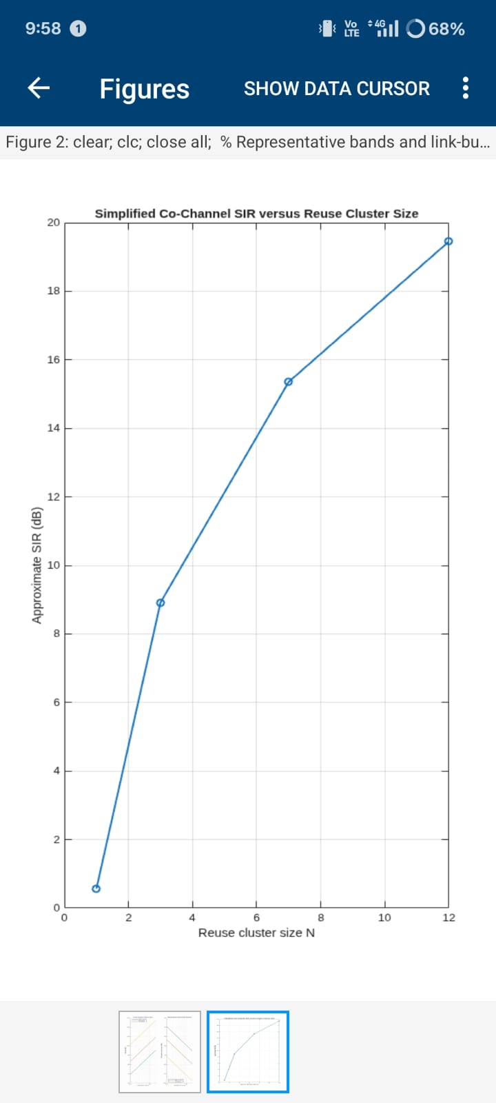
EXP:5
clc; clear; close all;
BW1 = 20; % Component carrier bandwidth (MHz)
SE = 4; % Spectral efficiency (bits/s/Hz)
Ncc = 1; % Number of component carriers
BWagg = BW1*Ncc;
Throughput = BWagg*SE; % Mbps for MHz × bits/s/Hz
disp('Single Component Carrier')
disp(['Bandwidth = ',num2str(BWagg),' MHz'])
disp(['Estimated Throughput = ',num2str(Throughput),' Mbps'])
figure
bar(Ncc,Throughput)
grid on
xlabel('Number of Component Carriers')
ylabel('Estimated Throughput (Mbps)')
title('LTE-Advanced Single Carrier Throughput')

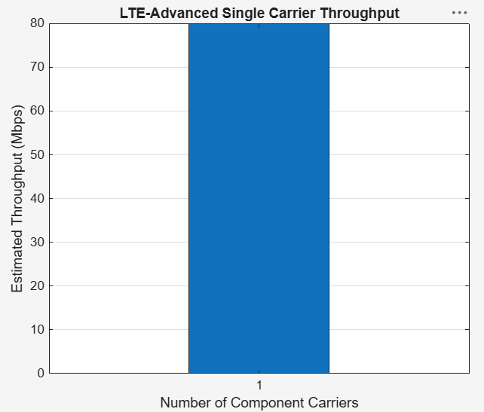

clc; clear; close all;
BWcc = 20; % MHz per component carrier
SE = 4; % bits/s/Hz
CC = [1 2 3]; % Number of component carriers
AggBW = BWcc .* CC; % MHz
Throughput = AggBW .* SE; % Mbps
disp('CC Aggregated BW (MHz) Estimated Throughput (Mbps)')
disp([CC' AggBW' Throughput'])

figure
bar(CC,Throughput)
grid on
xlabel('Number of Aggregated Component Carriers')
ylabel('Estimated Throughput (Mbps)')
title('LTE-Advanced Carrier Aggregation Throughput')

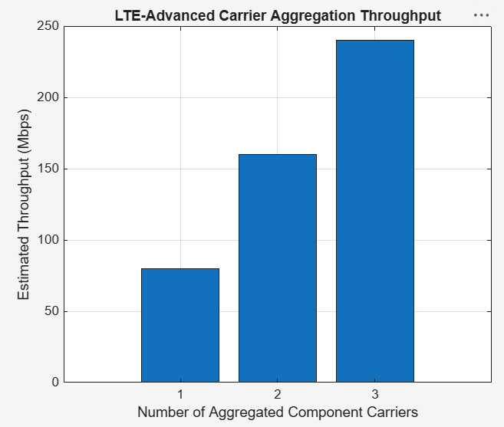

clc; clear; close all;
BW = [5 10 15 20]; % Carrier bandwidths (MHz)
SE = 4; % bits/s/Hz
TP = BW .* SE; % Estimated throughput (Mbps)
disp('Bandwidth (MHz) Throughput (Mbps)')
disp([BW' TP'])

figure
plot(BW,TP,'o-','LineWidth',2)
grid on
xlabel('Carrier Bandwidth (MHz)')
ylabel('Estimated Throughput (Mbps)')
title('Throughput vs Component Carrier Bandwidth')

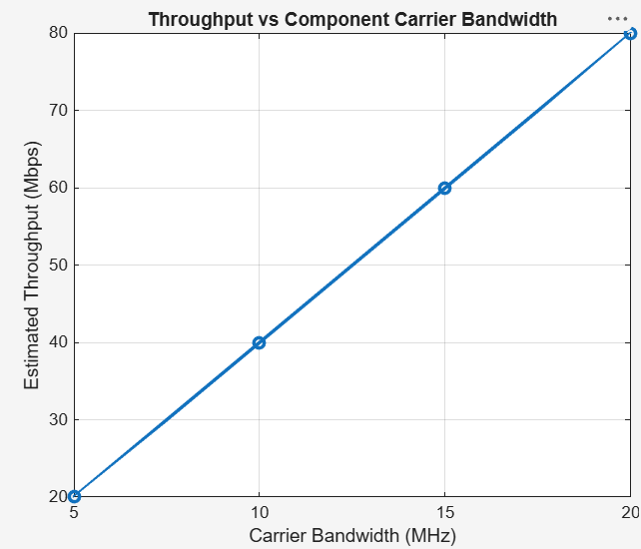
EXP:6
clc; clear; close all;
SNR_dB = 0:2:20;

BER_SISO = zeros(size(SNR_dB));
BER_MIMO = zeros(size(SNR_dB));
for k = 1:length(SNR_dB)
N = 10000;
bits = randi([0 1],N,1);
tx = 2*bits-1;
snrLin = 10^(SNR_dB(k)/10);
noise = randn(N,1)/sqrt(2*snrLin);
rx = tx + noise;
bits_hat = real(rx)>0;
BER_SISO(k) = mean(bits_hat~=bits);
% Simple 2x2 MIMO equivalent link
H = (randn(2,2)+1j*randn(2,2))/sqrt(2);
h_eff = sqrt(sum(abs(H(:)).^2)/2);
noise2 = randn(N,1)/sqrt(2*snrLin);
rx2 = h_eff*tx + noise2;
bits_hat2 = real(rx2)>0;
BER_MIMO(k) = mean(bits_hat2~=bits);
end
figure
semilogy(SNR_dB,BER_SISO,'o-','LineWidth',2); hold on
semilogy(SNR_dB,BER_MIMO,'s-','LineWidth',2)
grid on
xlabel('SNR (dB)')
ylabel('Bit Error Rate (BER)')
title('SISO and MIMO BER Performance')
legend('SISO','MIMO')
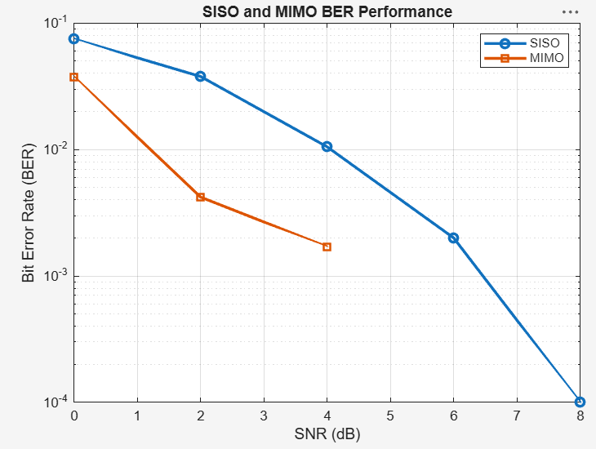

clc; clear; close all;
SNR_dB = 0:2:20;
Reliability = zeros(size(SNR_dB));
for k = 1:length(SNR_dB)
N = 10000;
bits = randi([0 1],N,1);
tx = 2*bits-1;
snrLin = 10^(SNR_dB(k)/10);
noise = randn(N,1)/sqrt(2*snrLin);
rx = tx + noise;
bhat = real(rx)>0;
BER = mean(bhat~=bits);
Reliability(k) = 1-BER;
end

figure
plot(SNR_dB,Reliability,'o-','LineWidth',2)
grid on
xlabel('SNR (dB)')
ylabel('Reliability (1-BER)')
title('Communication Reliability vs SNR')

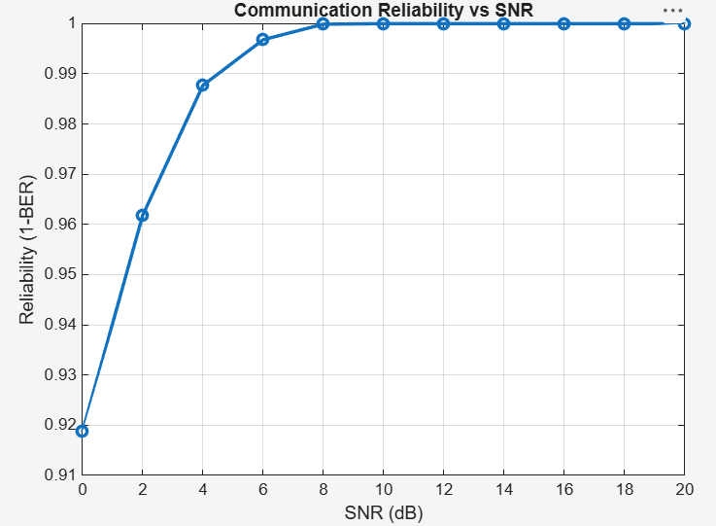
clc; clear; close all;
N = 8; % Antenna elements
theta = -90:1:90; % Observation angle
steer = [-60 -30 0 30 60]; % Steering directions
gain = zeros(size(steer));
for k = 1:length(steer)
% Simplified normalized array response at the intended direction
gain(k) = 10*log10(N) - 0.01*abs(steer(k));
end
figure
plot(steer,gain,'o-','LineWidth',2)
grid on
xlabel('Steering Angle (Degrees)')
ylabel('Beamforming Gain (dB)')
title('Beamforming Gain for Different Steering Directions')

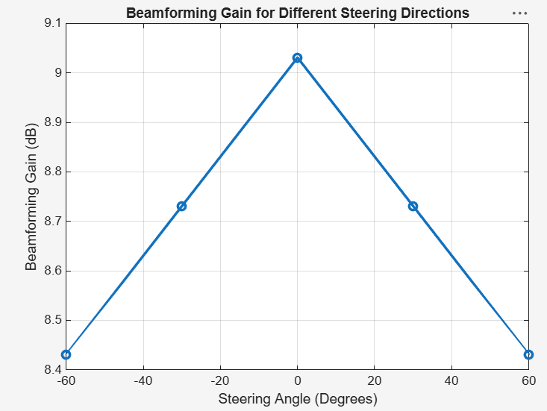

EXP:7
clc; clear; close all;
Nsc = 24; % Simplified number of subcarriers
Nsym = 14; % OFDM symbols per slot
grid = zeros(Nsym,Nsc);
% Simplified DL assignment: symbols 1-10
grid(1:10,:) = 1;
% Simplified UL assignment: symbols 11-14

grid(11:14,:) = 2;
figure
imagesc(grid)
grid on
xlabel('Subcarrier Index')
ylabel('OFDM Symbol Index')
title('Simplified 5G NR Time-Frequency Resource Grid')

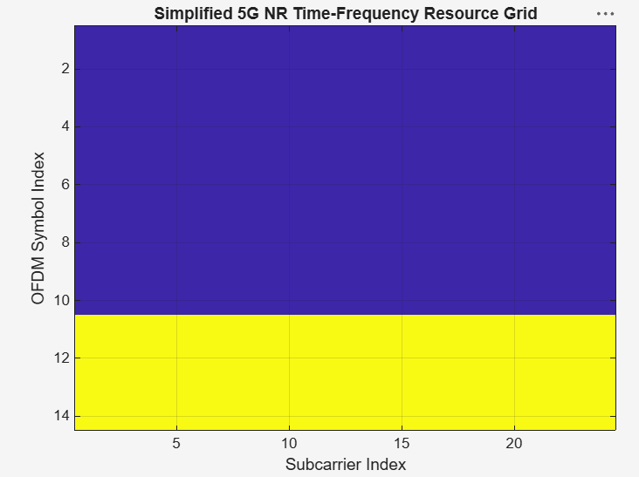

clc; clear; close all;
scs = [15 30 60 120 240]; % kHz
mu = 0:4;
slot = [1 0.5 0.25 0.125 0.0625]; % ms

figure
plot(scs,slot,'o-','LineWidth',2)
grid on
xlabel('Subcarrier Spacing (kHz)')
ylabel('Slot Duration (ms)')
title('5G NR Slot Duration for Different Subcarrier Spacing')
figure
bar(scs)
grid on
set(gca,'XTickLabel',mu)
xlabel('Numerology Index (\mu)')
ylabel('Subcarrier Spacing (kHz)')
title('5G NR Subcarrier Spacing for Different Numerologies')

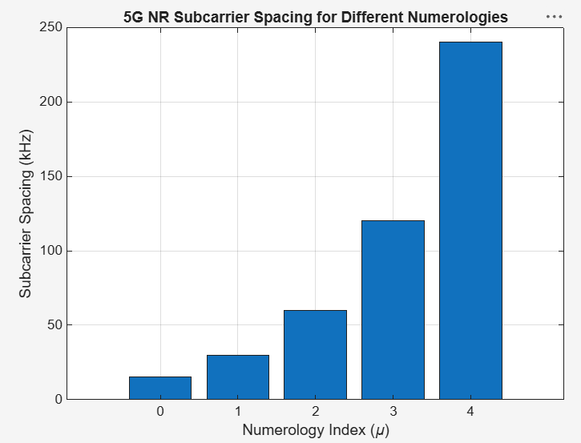

clc; clear; close all;
symbols = 1:14;
DL = [1 1 1 1 1 1 1 1 1 1 0 0 0 0];
UL = [0 0 0 0 0 0 0 0 0 0 1 1 1 1];
figure
plot(symbols,DL,'o-','LineWidth',2); hold on
plot(symbols,UL,'s-','LineWidth',2)
grid on
xlabel('OFDM Symbol Index')
ylabel('Allocation Status')
title('Simplified Downlink and Uplink Assignment')
legend('Downlink','Uplink')
